
To: | Dr. Thomas Mackin, Mechanical Engineering, Cal Poly SLO, tmackin@calpoly.edu
From: | Caiden Bonney
Date: | January 30, 2025
RE: | Week 2 Lab Assignment - Grip and Thread Stress Lab

Introduction:
Bolted connections are fundamental components in mechanical assemblies, commonly used to join structural and machine elements. Understanding their load distribution, stiffness, and stress concentrations is critical for ensuring reliable and efficient designs. This lab focuses on analyzing the mechanical behavior of a bolted joint under axial loading using both theoretical calculations and Finite Element Analysis (FEA).
This experiment is divided into two main sections: the Washer/Plates System and the Bolt/Nut System. The Washer/Plates System investigates the stiffness of the bolted grip using the Shigley frustum model, which provides a theoretical approach to estimating load distribution in the joint. The Bolt/Nut System examines the stress concentration in threaded fasteners, particularly focusing on how load is distributed among the first few engaged threads.
The primary objective of this lab is to compare theoretical predictions with FEA results to assess the accuracy of analytical models in predicting bolted joint behavior. Through this analysis, we aim to better understand the factors influencing stress distribution, deformation, and overall joint performance.

Experimental Procedure:
The experiment was split into two separate analyses, the Washer/Plates, and the Bolt/Nut. These were modeled separately to determine how each of them reacts to the expected loading placed on them. By modeling each assembly separately, we can more accurately match our theoretical loading for each system in FEA. This has the added benefit of ensuring that any unexpected errors in the FEA don’t affect the other systems analysis.

Washer/Plates System:
The Washer/Plates System consists of all the components within the bolted grip, the washer, the top plate, and bottom plate. Both plates have the same cross section but differing thicknesses. The cross-section of these plates is shown in Figure 1 as a 4in x 4in plate with a 0.5in diameter through-hole in the center. The washer’s cross-section is shown in Figure 2 with an outer diameter of 1.062in and an inner diameter of 0.531in, these dimensions were found in Table A-32 of Shigley’s Mechanical Engineering Design. The washer has a thickness of 0.095in, the top plate has a thickness of 0.5in, and the bottom plate has a thickness of 0.75in. The system as a whole is shown in Figure 3 where these thicknesses can be seen.
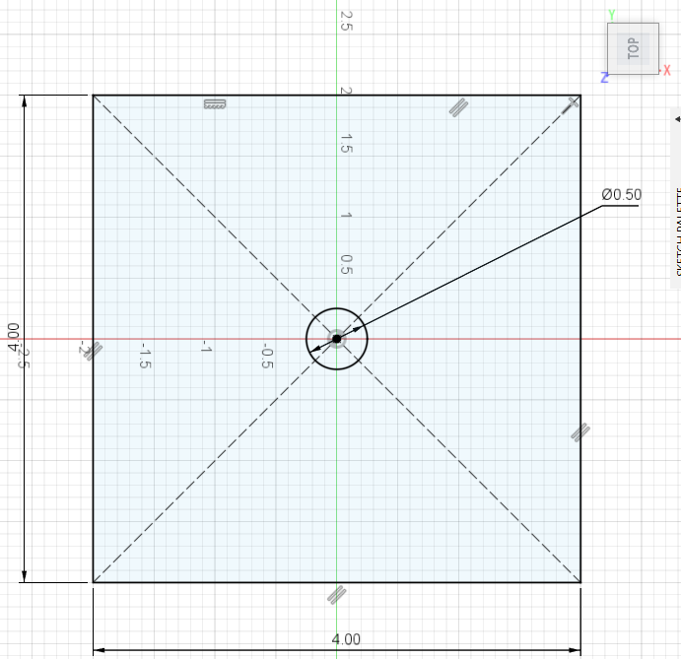
Figure 1. Top-View Cross-Section of the Modeled Plates with Bolt Through-Hole in the Center in Fusion 360.
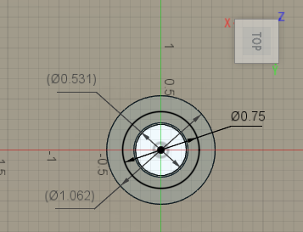
Figure 2. Top-View Cross-Section of Washer and Diameter of Split-Face for Force Analysis in Fusion 360.
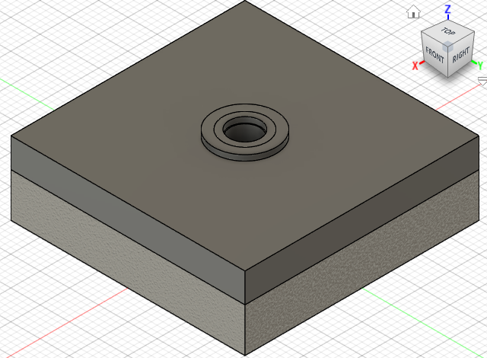
Figure 3. Isometric-View of the Washer/Plates System in Fusion 360, Note the different materials of the Washer and Top Plate and the Bottom Plate.
When modeling it’s imperative to note how important placing the forces in the correct way is. In this case this is shown through the area in which the force is acting upon the members. Usually bolts have a head diameter that is 1.5 x the diameter of the bolt. This head is what is applying the force to the members within the grip. To adjust for this a 1.5 x the diameter of the bolt (0.5in) split face was added on top of the washer. This is noted in Figure 2 where this results in a 0.75in diameter area in which the force of 4000lbf is being applied onto the members.
Equally important to the forces being applied in FEA are the constraints. In this model another split face of equal diameter is placed at the bottom of the bottom plate to represent the nut. A fixed constraint was placed on this split face to model when a nut is held in place and the bolt is tightened to apply the load to the members in the grip. An additional fixed constraint is placed on the edge of the corners of the plates however this one allows for movement in the vertical direction (z axis). This allows the plates to bend in due to the bolt loading without shifting as it is expected. These plates are part of a much larger part that needs to be joined together; therefore, these plates shouldn’t shift from one another in the x or y axis.
Finally, a mesh of 3% was used to accurately analyze the deflection of the plates under the loading.
Figure 4 was given in the experiment instructions and notes the thickness of the plates and washer as well as the expected values of the frustra for the stiffness calculations. These calculations were done in an Excel spreadsheet, a snapshot of which is provided in Figure 5.
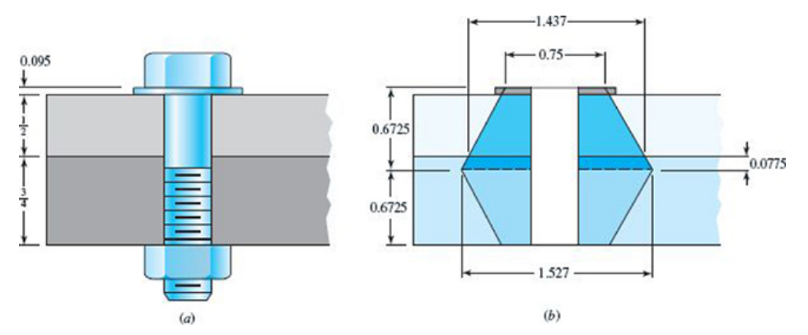
Figure 4. Given Plates and Washer Thickness and Expected of Frusta Dimensions for Theoretical Calculations.
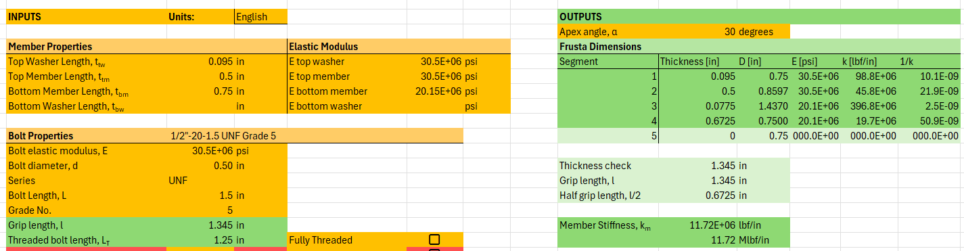
Figure 5. Excel Spreadsheet Inputs and Outputs for Theoretical Calculations of Frusta for Member Stiffness.
The member stiffness is determined by finding equivalent stiffness for each portion of the frustra starting at the loading diameter of 1.5 times the bolt diameter due to the expected loading. Each member has an input for elastic modulus in case each member was made of a different material. In this case the washer and the top member are both modeled out of steel, so the elastic modulus used in the FEA is noted for these members. The bottom member is modeled out of cast iron leading to a different elastic modulus for this member also matched to the value in FEA.
For each frustrum segment the thickness is determined before the diameter used at the top of the conical frustum is calculated. For each frustrum segment the elastic modulus must be determined as it can vary depending on which member the frustum segment is within. Finally, the elastic modulus of each of these frustum segments is calculated before being placed in series with one another to calculate the final member stiffness, k_{m} = 11.72 Mlbf/in.

Bolt/Nut System:
The Bolt/Nut system is much simpler, containing only two components, both of which the dimensions are given by their specification. The bolt is a ½-20 UNFx1½ Grade 5 Washer-faced Bolt. This callout refers to the bolt’s diameter of 0.5in, it’s a Fine-Pitch Series meaning it has a pitch of 20 threads per inch. The bolt is 1.5in long and has a grade 5 specification to denote the expected strengths of the bolt for yield and ultimate tensile. The nut was modeled as a regular hexagonal nut based on Table A-31 of Shigley’s Mechanical Engineering Design. It has a height of 0.4375in and a width of 0.75 from flat to flat for the 0.5 diameter of the chosen bolt.

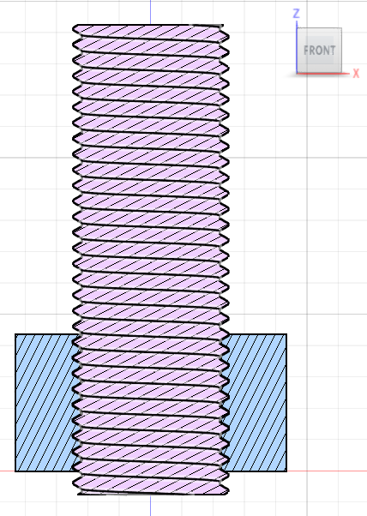
Figure 6. Front-View Cross-Section of Bolt/Nut System in Fusion 360.
The nut was offset by 1.5 thread lengths from the bottom of the threads to depict the standard practice for design of bolts with nuts, however based on the thicknesses of the members the bolt should have only been threaded a little over halfway through the nut (0.25in). To make a more representative study of bolts and nuts it was chosen to make this change to allow all of the threads of the nut to be used when securing the load. These two components were rotated to ensure that there was no interreference before the FEA began.
A 4000lbf force is place on the top of the nut depicted in Figure 6 pulling the bolt in tension by the force it will be torqued onto the members. The top of the bolt has a fixed constraint to represent the base of the head of the nut which applied the load onto the members, so any reaction forces are the forces exerted onto the members. Bolt and nuts are made to slide against one another, so a sliding contact was placed on the bottom side of the threads in the nut and the top side of the threads on the bolt so that the bolt has the freedom to slide as is expected.
The theoretical calculations for the bolt stiffness done in Excel are noted in Figure 7.
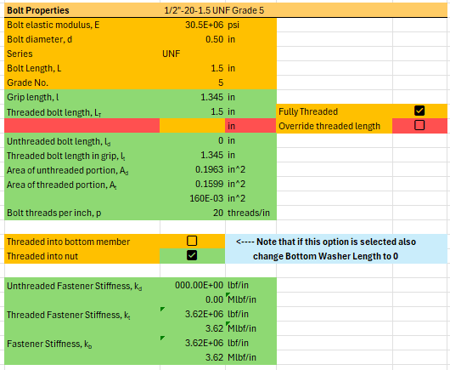
Figure 7. Excel Spreadsheet Inputs and Outputs for Theoretical Calculations of Bolt Stiffness.
All previously mentioned dimensions of the bolt are included as inputs into the spreadsheet shown in Figure 7. However, to match the bolt modeled in FEA the thread length was adjusted to be fully threaded to represent the model tested. Due to this there is no unthreaded portion of the fastener leading to a k_{d} of 0 and a k_{t} and subsequently final fastener stiffness of k_{b} = 3.62 Mlbf/in.

Results:

Washer/Plates System FEA:
Figure 8 depicts the loading being applied to the Washer/Plate System.
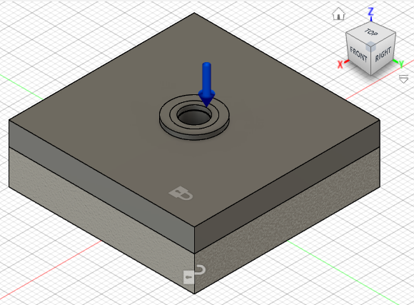
Figure 8. Loading of Washer/Plates System in Fusion 360.
Before further analysis of the stress found by the FEA let’s start by checking if the reaction forces on the bottom plate are reasonable in Figure 9.
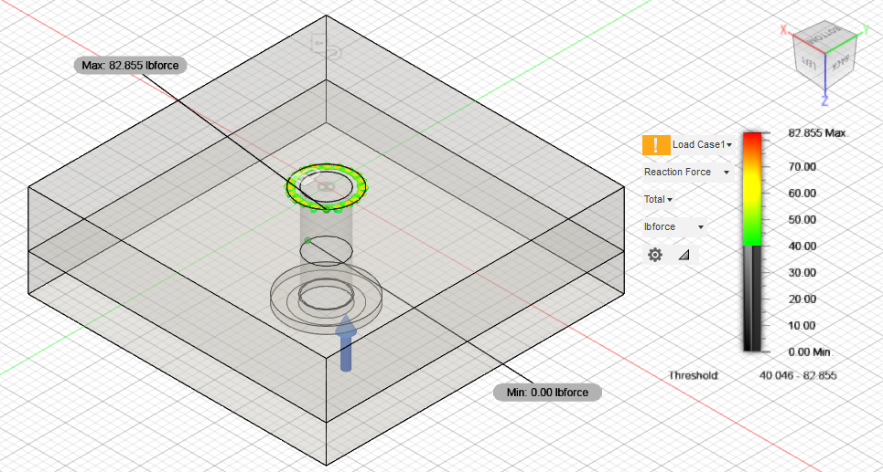
Figure 9. Reaction Forces of Washer/Plates System in Fusion 360.
Ignoring the spikes directly at the fixed constraint which may lead to error, the overall reaction forces make sense around the 4000lbf range which was the loading being applied and was expected from the nut on the bottom plate.
The displacement plot for the Washer/Plates System with a bottom plate of cast iron can be seen in Figure 10.
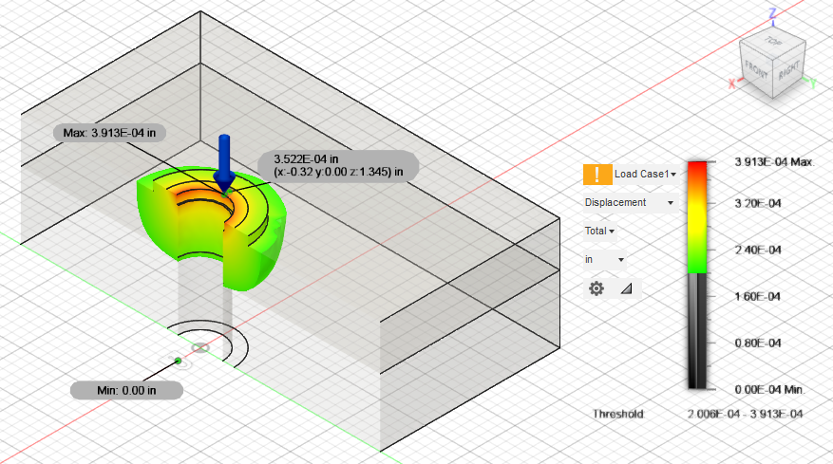
Figure 10. Displacement of Washer/Plates System in Fusion 360 with a bottom plate of cast iron and a midpoint displacement shown.
Using Hooke’s Law to calculate the member stiffness,
$$\begin{aligned}F=kx\end{aligned}$$
$$\begin{aligned}k=\frac{F}{x}\#\left(1\right)\end{aligned}$$
Where F is the 4000 lbf applied and x is the displacement of 3.522E-4inches determined from Figure 10. The resulting member stiffness is $k_{m,exp}=11.375×{10}^{6}\frac{lbf}{in}$. This was then compared to the theoretical value from the spreadsheet in Figure 5 $k_{m,theo}=11.72×{10}^{6}\frac{lbf}{in}$. Using the percent error equation,
$$\begin{aligned}\% Error= \frac{\left|Measured Value-Theoretical Value\right|}{Theoretical Value}×100 \#\left(2\right)\end{aligned}$$
Where the Measured Value is the $11.375×{10}^{6}\frac{lbf}{in}$ from Fusion 360 and the Theoretical Value is the $11.72×{10}^{6}\frac{lbf}{in}$ from the spreadsheet. The results yield a percentage error of 3.07%. This is a very low error giving high confidence in the setup of both the simulation and the theoretical spreadsheet. The stress distribution of this loading is depicted in Figure 11.
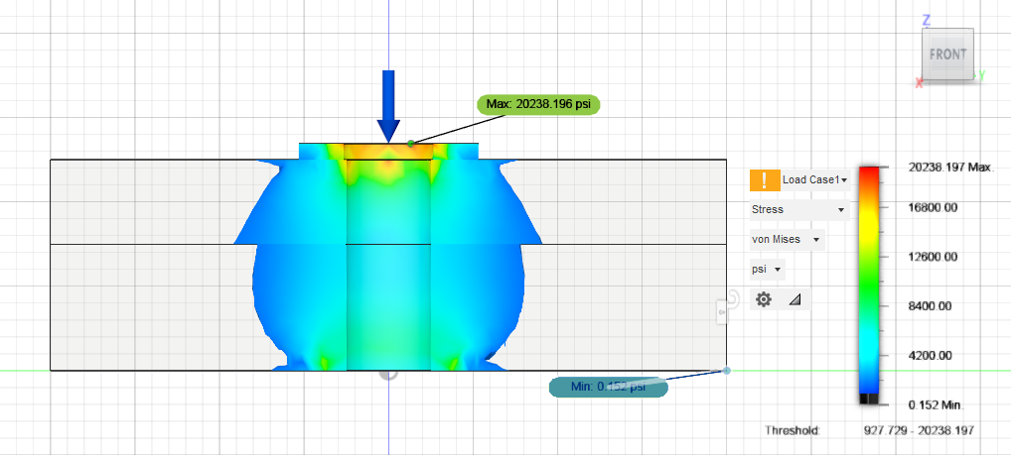
Figure 11. Front-View Cross-Section Results of FEA of Washer/Plates System in Fusion 360 with a bottom plate of cast iron, denoting conical frustum.
As can be seen in Figure 11 the stress distribution of the FEA matched quite closely to that shown in Figure 4 which depicted the frustrum dimensions. Both exhibit the conical increase in stress until reaching the midpoint at which it decreases conically back to the previously calculated 0.75 frustrum diameter at the bottom plate. There was a large change in stress between the top plate and the bottom plate however, this is to be expected as they have different elastic moduli. To test whether this change in elastic modulus was indeed the reason for the quick change of stress, the test was conducted a second time however with the bottom plate also adjusted to be steel Figure 12.
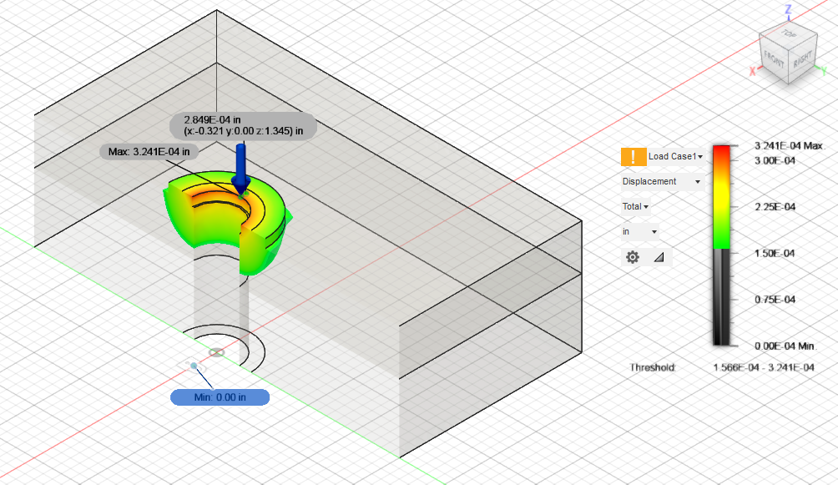
Figure 12. Displacement of Washer/Plates System in Fusion 360 with a bottom plate of steel and a midpoint displacement shown.
After adjusting the bottom plate to steel the displacement was calculated to be 2.849E-4 which was then converted into a member stiffness of $k_{m,exp}=14.04×{10}^{6}\frac{lbf}{in}$ through the use of Equation 1. This was then compared to the theoretical value from the spreadsheet in Figure 13.
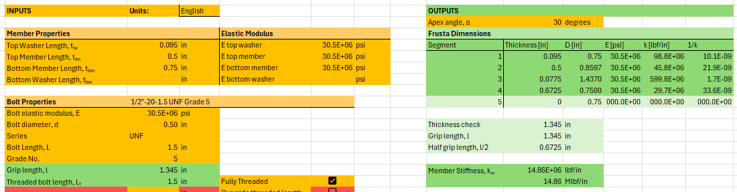
Figure 13. Excel Spreadsheet Inputs and Outputs for Theoretical Calculations of Frusta for Member Stiffness after adjusting the bottom plate to be steel.
The calculated member stiffness is $k_{m,theo}=14.86×{10}^{6}\frac{lbf}{in}$. Using the percent error equation, Equation 2, the percent error was calculated to be 5.53%. This is also quite a small error percentage for experiments involving FEA as there can be small mistakes that can lead to huge errors in the end. Running the analysis for the Von Mises stress yielded Figure 14.
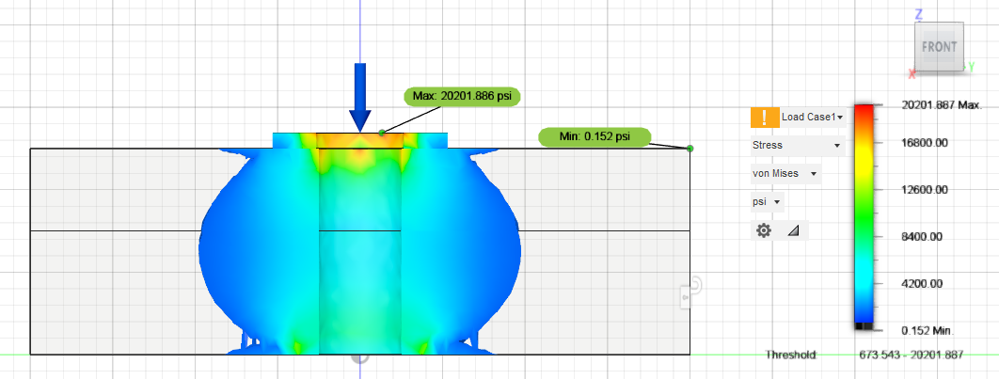
Figure 14. Front-View Cross-Section Results of FEA of Washer/Plates System in Fusion 360 with a bottom plate of steel, denoting conical frustum.
Comparing Figure 14 to Figure 11, my prediction of a different elastic modulus was the reason for the abrupt change in stress and the curve is much closer to the expected ideal theoretical model shown in Figure 4.

Bolt/Nut System FEA:
Depicted below are the results of the Bolt/Nut System described above, Figure’s 15 and 16 depict the bolt and nut stresses together slowly incrementing the lower limit. It’s generally accepted that the First three threads carry the majority of the load. This can be seen as there is more material with higher stress in the top of the nut than the base of the nut. It’s unknown why the FEA did not represent the stress as evenly distributed across the whole thread and focused single lines. On careful inspection it was observed that these lines start at the point of a mesh triangle section which could artificially increase the load due to the point of the section. This trend also continued for the nut analysis in Figure 17.
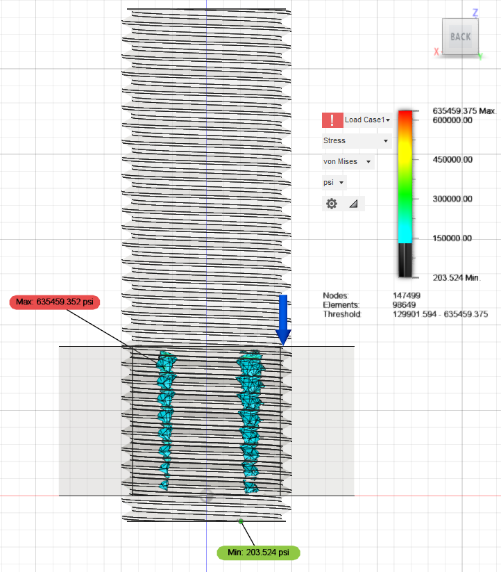
Figure 15. Von Mises of Bolt/Nut System Together in Fusion 360.

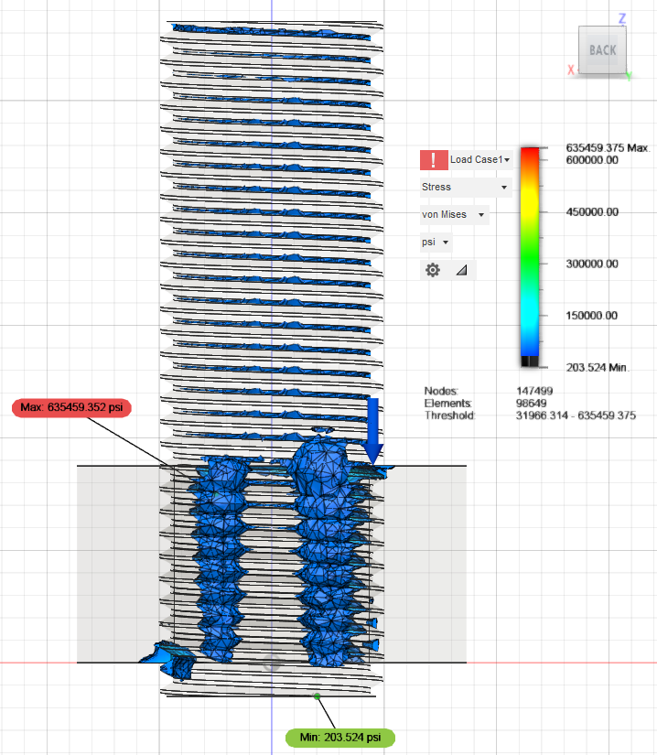
Figure 16. Von Mises of Bolt/Nut System Together in Fusion 360.
Hiding the bolt to more easily see the stresses on the threads of the nut it’s easily seen how the stress is higher in the first threads than the rest.
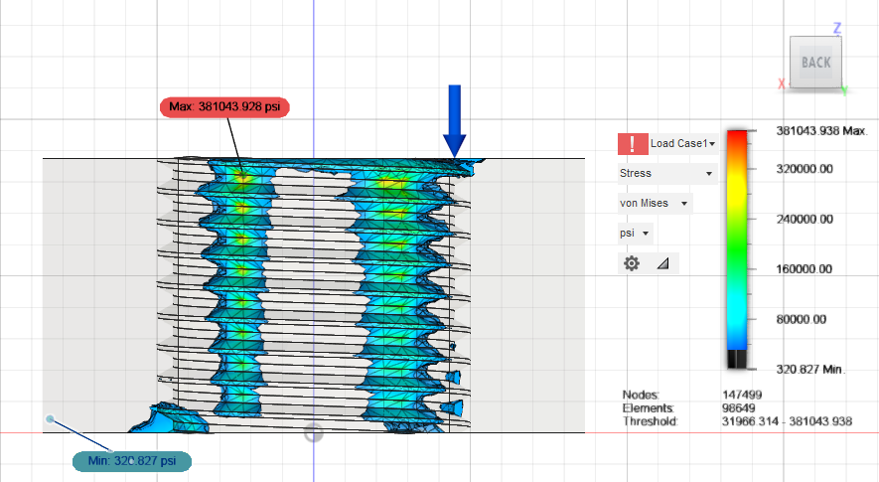
Figure 17. Von Mises of Bolt/Nut System depicting Only the Nut in Fusion 360.
It’s remarkable how similar the simulation of the stress on the threads is to the theory giving me high confidence that the modeling of the Bolt/Nut System was done correctly when disregarding the missing areas between the shown “lines” of stress.

Conclusion:
By analyzing the Washer/Plates System and the Bolt/Nut System, we were able to isolate the effects of different materials, loading conditions, and constraints to better understand how these components respond to applied forces.
For the Washer/Plates System, the FEA results closely matched the theoretical predictions, with a small percentage error of 3.07% for the steel/cast iron configuration and 5.53% for the all-steel configuration. These results confirmed that the Shigley frustum model accurately predicts the load distribution and stiffness of the bolted grip. The displacement and stress distributions from the FEA simulations also closely followed theoretical expectations, reinforcing confidence in the setup and methodology used.
The Bolt/Nut System analysis showed that the highest stresses occurred at the first few threads of the nut, aligning with the commonly accepted theory that the first three threads carry the majority of the load. However, minor discrepancies in the stress distribution were observed, likely due to meshing limitations in the FEA. Despite this, the overall trend and results were consistent with theoretical expectations, validating the accuracy of the model.
Overall, this lab demonstrated the importance of proper load application, material selection, and constraint setup in FEA simulations. The close agreement between theoretical and simulated results confirms that the models were well-constructed, and that FEA is a reliable tool for predicting the mechanical behavior of bolted assemblies. Future improvements could involve refining the mesh in the Bolt/Nut System to better capture stress distribution across the threads and further exploring the effects of different materials and fastener geometries on load distribution and stiffness.

